using System;

using System.Collections.Generic;

using System.ComponentModel;

using System.Data;

using System.Drawing;

using System.Linq;

using System.Text;

using System.Threading.Tasks;

using System.Windows.Forms;

namespace Cancule

{

public partial class Form1 : Form

{

public Form1()

{

InitializeComponent();

}

string a,op,b;

int res;

private void button1_Click(object sender, EventArgs e)

{

if (textBox1.Text == "0")

textBox1.Clear();

if(res==1)

{

textBox1.Text = button1.Text;

res = 0;

}

else

textBox1.Text += button1.Text;

// a += button1.Text;

}

private void button6_Click(object sender, EventArgs e)

{

if (textBox1.Text == "0")

textBox1.Clear();

if (res == 1)

{

textBox1.Text = button6.Text;

res = 0;

}

else

textBox1.Text += button6.Text;

// a += button6.Text;

}

private void button7_Click(object sender, EventArgs e)

{

if (textBox1.Text == "0")

textBox1.Clear();

if (res == 1)

{

textBox1.Text = button7.Text;

res = 0;

}

else

textBox1.Text += button7.Text;

// a += button7.Text;

}

private void button2_Click(object sender, EventArgs e)

{

if (textBox1.Text == "0")

textBox1.Clear();

if (res == 1)

{

textBox1.Text = button2.Text;

res = 0;

}

else

textBox1.Text += button2.Text;

// a += button2.Text;

}

private void button5_Click(object sender, EventArgs e)

{

if (textBox1.Text == "0")

textBox1.Clear();

if (res == 1)

{

textBox1.Text = button5.Text;

res = 0;

}

else

textBox1.Text += button5.Text;

// a += button5.Text;

}

private void button9_Click(object sender, EventArgs e)

{

if (textBox1.Text == "0")

textBox1.Clear();

if (res == 1)

{

textBox1.Text = button9.Text;

res = 0;

}

else

textBox1.Text += button9.Text;

// a += button9.Text;

}

private void button3_Click(object sender, EventArgs e)

{

if (textBox1.Text == "0")

textBox1.Clear();

if (res == 1)

{

textBox1.Text = button3.Text;

res = 0;

}

else

textBox1.Text += button3.Text;

// a += button3.Text;

}

private void button4_Click(object sender, EventArgs e)

{

if (textBox1.Text == "0")

textBox1.Clear();

if (res == 1)

{

textBox1.Text = button4.Text;

res = 0;

}

else

textBox1.Text += button4.Text;

// a += button4.Text;

}

private void button8_Click(object sender, EventArgs e)

{

if (textBox1.Text == "0")

textBox1.Clear();

if (res == 1)

{

textBox1.Text = button8.Text;

res = 0;

}

else

textBox1.Text += button8.Text;

// a += button8.Text;

}

private void button10_Click(object sender, EventArgs e)

{

if (textBox1.Text == "0")

textBox1.Clear();

if (res == 1)

{

textBox1.Text = button10.Text;

res = 0;

}

else

textBox1.Text += button10.Text;

// a += button10.Text;

}

private void button13_Click(object sender, EventArgs e)

{

if (textBox1.Text == "0")

textBox1.Clear();

textBox1.Text = "0";

a = " 0";

label1.Text = a;

}

private void button12_Click(object sender, EventArgs e)

{

}

private void button18_Click(object sender, EventArgs e)

{

int a;

a = (int)MessageBox.Show("Do You Want Turn On/Off?","r u sure", MessageBoxButtons.YesNo, MessageBoxIcon.Question);

if (a == 6)

{

groupBox1.Enabled = true;

}

if(a!=6)

{

groupBox1.Enabled = false;

}

}

private void button14_Click(object sender, EventArgs e)

{

a = textBox1.Text;

op = "*";

if (textBox1.Text != "0")

{

textBox1.Text = "0";

}

label1.Text = a;

}

private void button16_Click(object sender, EventArgs e)

{

a = textBox1.Text;

op = "-";

if (textBox1.Text != "0")

{

textBox1.Text = "0";

}

label1.Text = a;

}

private void button17_Click(object sender, EventArgs e)

{

a = textBox1.Text;

op = "+";

if (textBox1.Text != "0")

{

textBox1.Text = "0";

}

label1.Text = a;

}

private void label1_Click(object sender, EventArgs e)

{

}

private void button11_Click(object sender, EventArgs e)

{

a = textBox1.Text;

op = "/";

if (textBox1.Text != "0")

{

textBox1.Text = "0";

}

label1.Text = a;

}

private void button15_Click(object sender, EventArgs e)

{

b = textBox1.Text;

if (op == "/")

{

textBox1.Text = (int.Parse(a) / int.Parse(b)).ToString();

}

if (op == "*")

{

textBox1.Text = (int.Parse(a) * int.Parse(b)).ToString();

}

if (op == "+")

{

textBox1.Text = (int.Parse(a) + int.Parse(b)).ToString();

}

if (op == "-")

{

textBox1.Text = (int.Parse(a) - int.Parse(b)).ToString();

}

res = 1;

label1.Text = textBox1.Text;

}

}

}

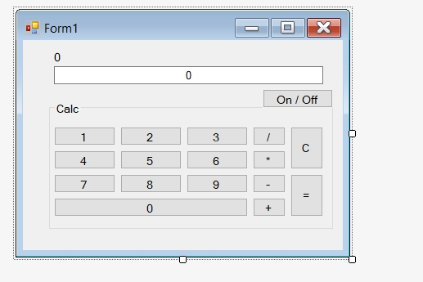  
  
first u create the look   
  
 create int \string what easier for u I used 3 (a,b,res)  
a=for first number text  
b=for second number text  
res=to restart that it won’t double click when u click one of the numbers  
  
double click all buttons  
and enjoy of follow the code